Quiz 1 ***(CSE331L.7 – Asif Ahmed Neloy_Summer’20)***

Department of Electrical and Computer Engineering

School of Engineering and Physical Sciences

North South University, Bashundhara, Dhaka-1229, Bangladesh

*Time 20 minutes, Marks 20 (You need to answer all questions).*

***Name –Rafiqul hasan sakib***

***ID -1510797042 7/10***

1. **Why it is never a good idea to store any data in the segment registers?[5]**

Although it is possible to store any data in the segment registers, but this is never a good idea. The segment registers have a special purpose pointing at accessible blocks of memory so it is bad idea to store any data in segment register.

1. **Write a program in Assembly language that will add 4 integer number (1,2,2,1) using only AX register and Store the result in the AX register.**

**org 100h**

**MOV AX,1**

**ADD AX,2**

**ADD AX,2**

**ADD AX,1**

**ret**

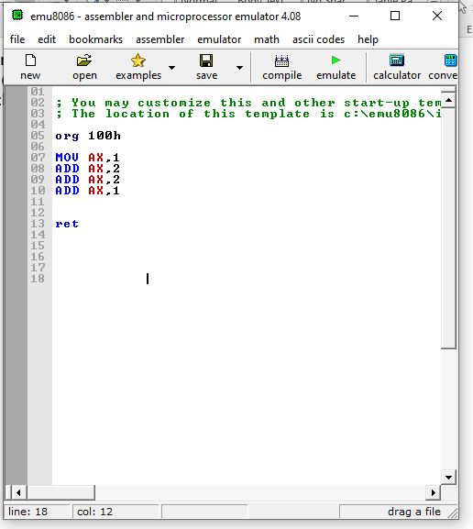

**End**